Data: https://data.un.org/
Predominantly focusing the analysis on GDP for simplicity.
Steps:
- Reading in data from UN Dataset (only selected a few .csv files – there are many more that could be added)
- Cleaning up data such that we only have country-specific data for 2010 and 2015, as well as GDP data for all countries from 1995-2015. Analyzing data just in 2010/2015 gave me the most data to work with in terms of the other variables.
- Imputing values so that analyses can be performed (using forward/backward fills for time data and KNN Imputation for other data). Not sure if data would be missing in Infinity implementation but can explore more methods to do this if needed.
- Answering questions below

- Which of these variables, if any, follow a normal distribution?
Methods to determine distributions:
- QQ Plots (graphically) – graph two variables and see if they follow the same distribution
- Probability Plots (graphically) – graph a variable and see if it follows some set distribution
- Shapiro-Wilk Test – good for <50 data points, generalizes ok to larger datasets
- Kolmogorov-Smirnov Test – good for >50 data points, example of this in my code
- What variables are strongly correlated with GDP in 2010? 2015?
- Do the distributions of GDP in 2010 vs. 2015 have equal variance?
- Does the GDP of country A differ from 2010 to 2015 by a statistically significant amount?
- Does the GDP differ between country A to country B by a statistically significant amount?
- Does the GDP differ among regions A, B, and C by a statistically significant amount over all years?
- Is the number of women in parliament (can be any variable) statistically significant in determining whether a country will have a high GDP in 2015?
- What variables are most significant in determining a country’s GDP in 2015?
- Which variables might be confounding variables?
- Which variables might interact with one another?

Broader Questions:
- Predict a country’s GDP 5 years into the future.
- Suppose we were to cluster these countries. What variables would define each cluster?
- What countries are anomalies?
- Perform time series analysis on GDP data. What trends do we see?
- Suppose a country wants to improve its GDP. What should it focus on?
- Suppose we modify the variables of country A. How would its expected GDP change? How about its expected GDP 5 years into the future?

Tests to determine normality: https://www.youtube.com/watch?v=uI0bXSCG-NA
- Check skewness (absolute value of .8 indicates non-normality), kurtosis (absolute value of 3 indicates non-normality)
- Shapiro-Wilk generally preferred as it has greater statistical power
- However tests need to be complemented with graphical methods such as histograms and QQ plots to determine normality for certain
- One solution for moderate datasets might be to run both Shapiro-Wilk and K-S and then output QQ plots for data where there seems to be a discrepancy so the user can check visually
  - K-S is typically used for larger sample sizes but Shapiro-Wilk has more statistical power for smaller data sets
  - Honestly lots of different approaches – some people say only use Shapiro-Wilk, some people say use K-S for larger sample sizes, some say rely more on visual data
  - With larger data sets, CLT will allow us to generally assume a normal distribution
    - So some say we can use t-tests with sample sizes greater than 40
Example – K-S says this is normal but S-W says it’s not. I would say it’s not normal based on the QQ plot 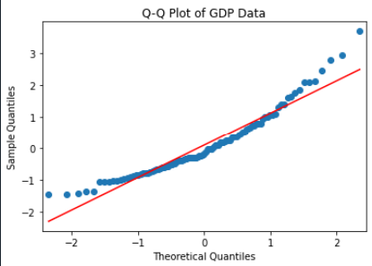

To do/Questions:
- Go through the data and plot discrepancies between tests of normality (K-S and S-W) in the GDP dataset, determine whether one might be better than the other since the literature is unclear
- Modify code to allow for reading from different files rather than one merged file, re-run LLMs to see how this changes analysis
- Try prompting LLMs to see whether this changes the results
- Look into descriptive statistics for numerical/non-numerical data – how can we make this analysis richer?
  - Use LLMs to see results
- Begin writing code for broader questions, clustering analysis

Numerical/non-numerical
- Min, max, standard deviation, mode, distribution
- How to make this richer?
- Most frequent, missing values, analyze count distribution

